Name:__________________________ Class 6._____ (Write A, B, or C)

Each question has four pictures. Three go together, and one is different. Write at least one complete sentence about which picture is different and why.
(Každé cvičení má čtyři obrázky. Tři patří k sobě a jeden je jiný. Napište alespoň jednu úplnou větu o tom, který obrázek je jiný a proč.)

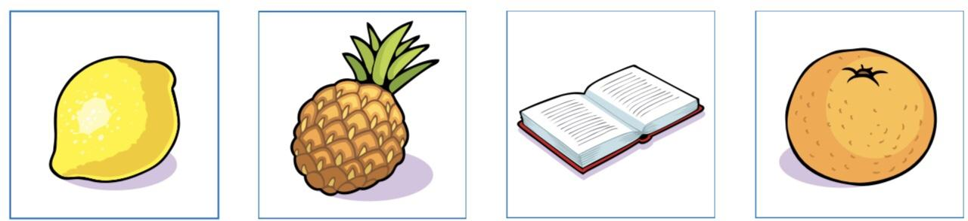

_______________________________________________________________________________________________________________________________________________________ .

2. 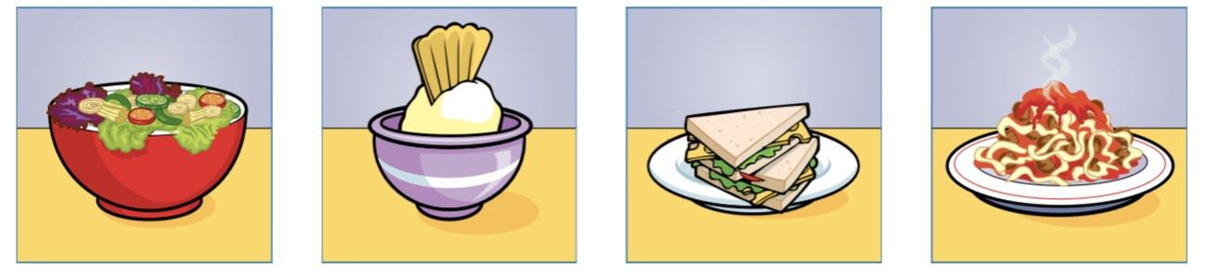
_______________________________________________________________________________________________________________________________________________________ .

3. 
_______________________________________________________________________________________________________________________________________________________ .

4. 
 

